WEBSITE TAKE II
Very general remark / question: Overall, I like the cream tone, but I feel like on the website, I will have a hard time making the imaginary work… is there a way we can add a third more “white” tone?
I think we are on the right track, but I still feel it needs quite some refinement visually, and then we need to make sure of many things functionally (in terms of accessibility as well)
Home Page
- Cookies display : The cookies display is still the same as before, I had this comment in the previous notes:, can we make it a lot more subtle? Firstly, it should be in the brand color, not plain white, secondly, I like a lot the approach of Paynter below (https://paynter.co.uk) It is subtle and you can click on “learn more”, if you wanted more info. I think we should minimize the content, I like having the small bar as below.
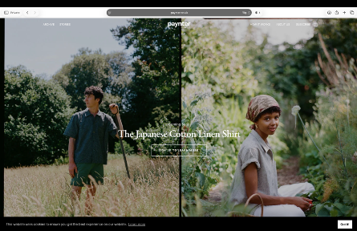
- Hero Image: The Hero Image section needs to accommodate video as well
- Collection I (below) needs to link to the shop
- Product cards on the home page: All the product cards need the functionality of marking as favorite and quick add (but please see quick add notes below). Also, this needs to incorporate swiping through images with arrows
- The price should also be below the title, not to the right to have white space
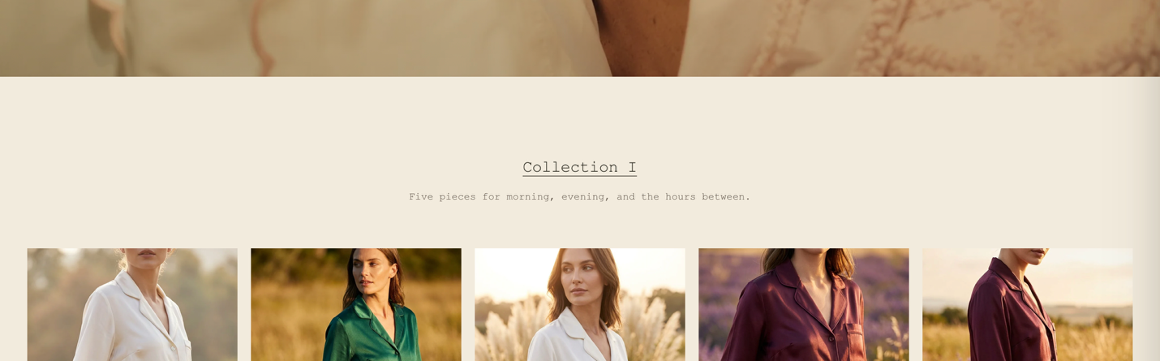
Header
- Shop: This needs to accommodate a menu (for the future) – how is this going to be (I will need to be able to build it up further, once we have more collections / categories)
- The country / currency selector currently only supports “United Kingdom – CHF” – is this something I need to change on my end?

Cart
- Overall: I find that the cart looks quite “clunky”, not elegant or refined, many things (also in the product cards still) are too big, there is no clear hierarchy where the eye flows…
- Slide-In: The slide in of the cart is nice, we should have that as well when adding something to the cart (that is currently not the case)
- Cart (1) is written way too big
- Paypal: I don’t want this that prominently, also we will need Apple Pay too – is this being pulled automatically
- Hierarchy: The hierarchy of font is still not really refined as I would like to, I feel there is not enough white space. The price sits very awkwardly besides the super big header and the Color: and Size: is also not flattering.
  - Size: Please use “S” etc. throughout
  - Checkout Button: Please make it in the black color
  - Heading: Is too big, it should not force a line break
  - Price: My suggestion would be to move the price also below the header, not to the right, to have white space top right
- Icon vs. font: I would still like to know your take on writing “cart” vs. having an icon, since almost all brands use an icon so writing it (also in terms of accessibility) is quite a unique choice.
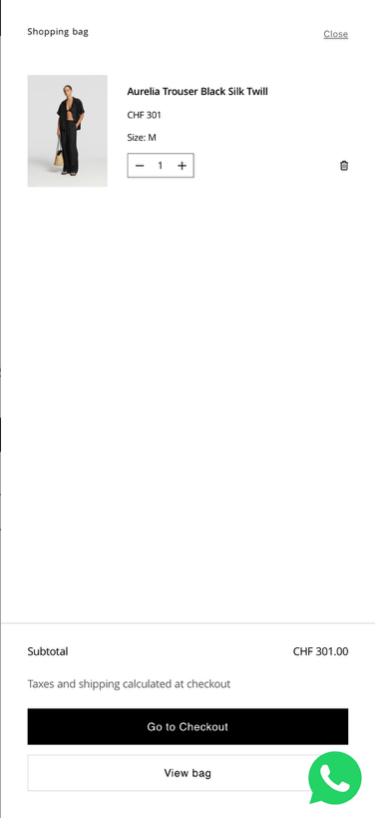
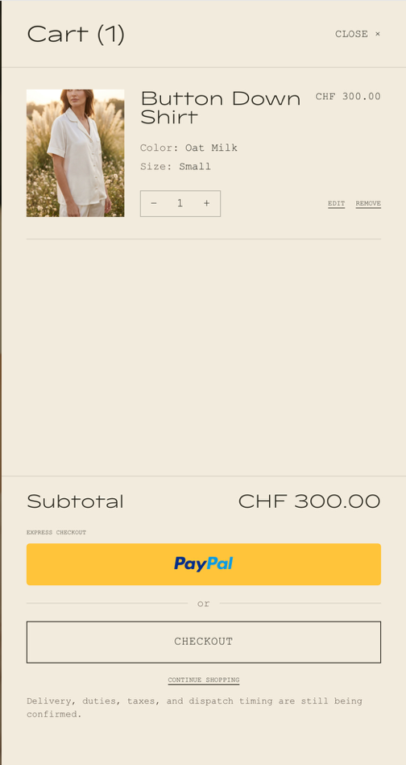
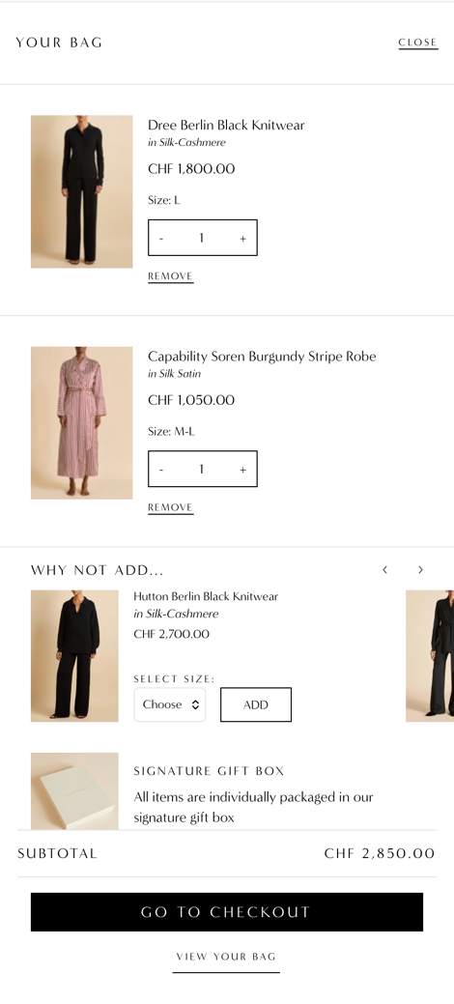

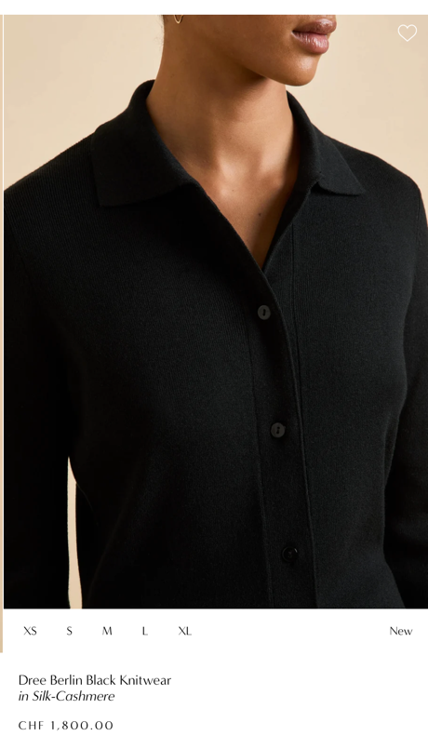
Product Cards / Shop
Can you please have a look at these product cards, I am not happy how it currently looks, there is way too much info displayed, which should only appear once someone hovers over the image. Please look at these examples again:
https://oddmuse.co.uk/en-ae/collections/all
https://oliviavonhalle.com/collections/all-products
- Image Size: Too big, min, 4 images per row, it is too clunky like this
- Info / Hierarchy / quick add: The quick add should only enable once someone hovers over a product. The size should then become visible, the customer can select and add to cart. Please refer to the two example above. Once selected, the cart should “slide” in from the right (please see below, this only appears once someone hovers over the product). The color I will do per product, so no need to have the color selector. That can be on the product page though. The price should not be on the right but below the headline of the item.
- Favorite: I would put the heart where the price is currently, without any circle around it, to make it more subtle
- Sold Out: If an item is not available and someone clicks on the size, a pop up should come to subscribe to “notify me when it is available) (please refer to the flow from Odd Muse)
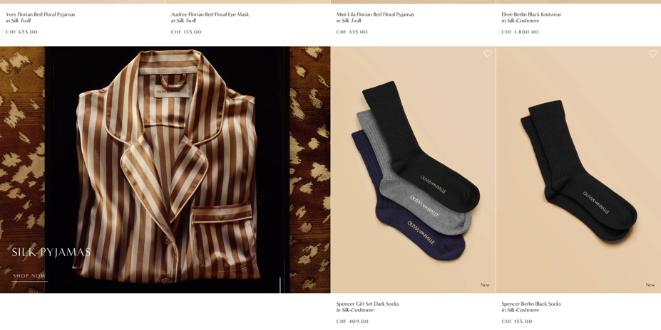
- Flexibility / Layout product page: Is it possible to allow for the layout that, if I want to, I can add also some campaign images (like below)?
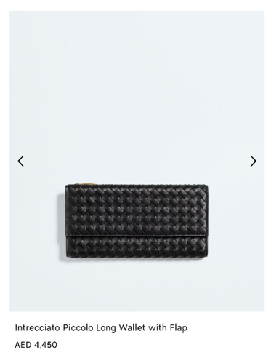
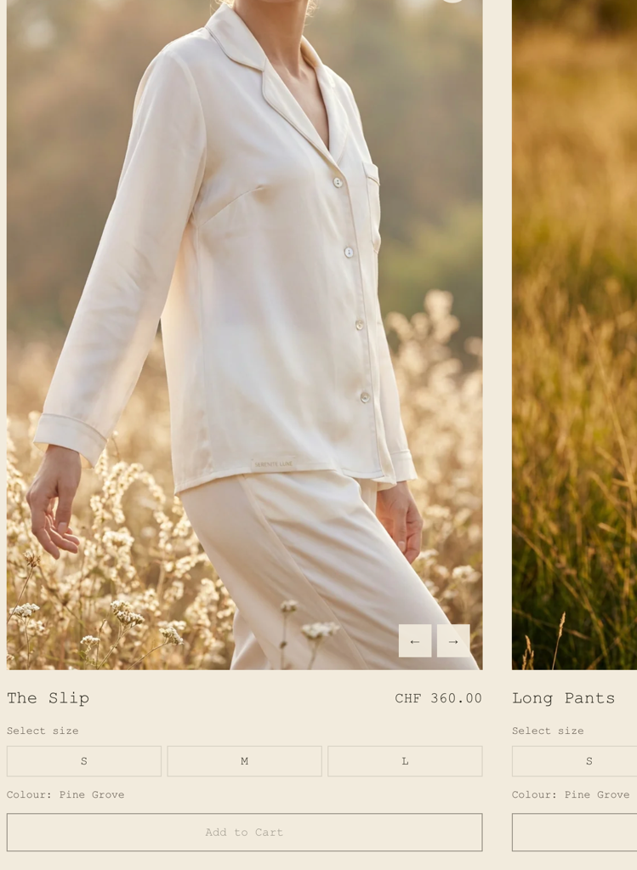
- Arrows: I would have the arrows in the middle of the product cart and minimal, without the background (like below) – like Botega Veneta: https://www.bottegaveneta.com/en-ae/women-collection-ae/women-wallets?utm_source=google&utm_source_platform=SA360&utm_medium=cpc&utm_campaign=AE%7CEN%7CSRC%7CBrand%7CSLG%7CU%7C%2F&utm_id=21172350906&gclsrc=aw.ds&gad_source=1&gad_campaignid=21172350906&gbraid=0AAAAADoepBtKe3QLHNJqOp7vshqQM2p2Z&gclid=CjwKCAjwiL7VBhA-EiwAhZi9EHUSSnegxtRdESOGY9tjvJkbYw53gLaTi--NdlEjh98mJtKLlUfLMxoCjq8QAvD_BwE
- Filter: This needs to be refined too, the filter should a) be multi-selection, I would not make it a drop-down, a customer should immediately see the options available and choose – either like below with the size (OvH), or tick boxes please. This only applies once we have more pieces but the functionality should allow to display the number of items after the filter is applied (as below)
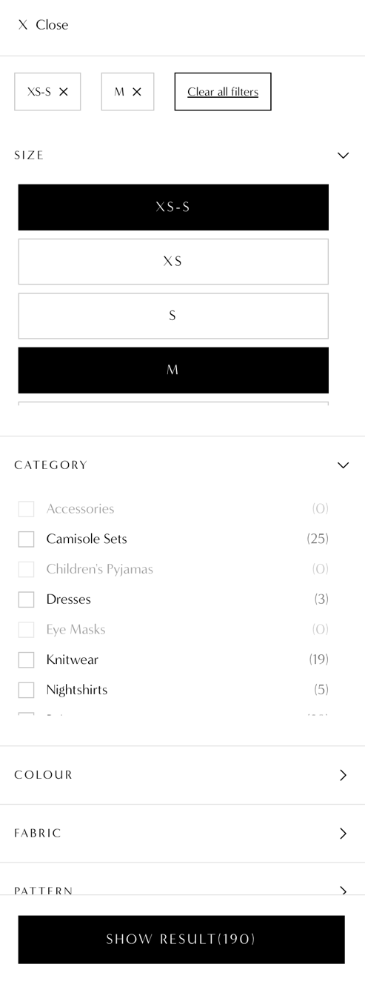
- Sorting: General comment: I don’t like these big boxes, can we make this a lot more subtle please? For the filter, I think we can remove the “date” filter
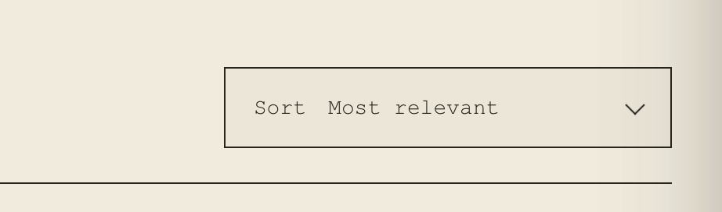
Footer:
- Do we need a separate page for the size guide, or can it just be part of the flow from the product page?
- Is “time well kept” and “Privacy” needed at the very bottom? Otherwise remove

Comment on font hierarchy: For example on this page, some of the font is tiny, barely readable… Please establish a clearer hierarchy to avoid clutter (and will also be a lot easier for me to make it coherent going forward)

It is the same with the Contact Page
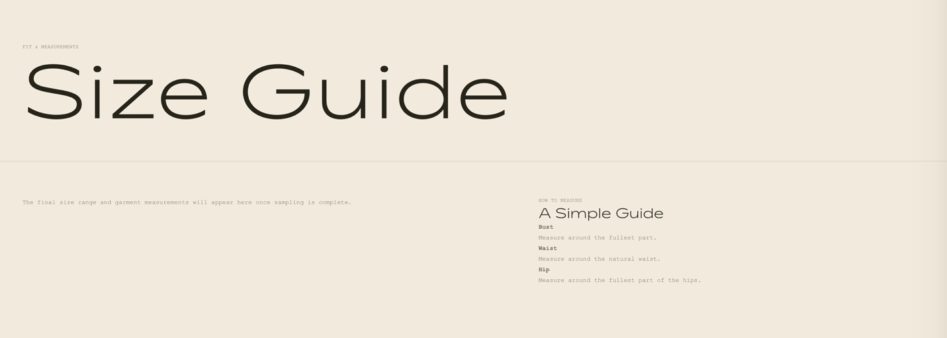

About
- Founder Note text formatting is a bit odd – can we refine that?
- I would love more white space please with the image / more intentional placing, and please allow also for video to be uploaded

